**Writing with Anna**

# Creative Writing:

Theme: Which is worse, failing or never trying?

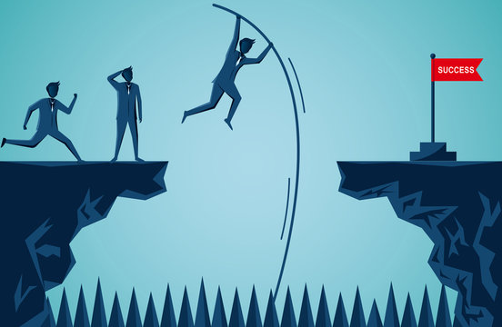

# Write a story about a story that compares and contrasts a character that tries (and maybe fails) and a character that does not try. What does each character learn in the process?